**ST.LUKE BAANABAKINTU PRIMARY SCHOOL**

**QUALITY CHECK EXAMINATIONS 2024**

**PRIMARY ONE**

Name:…………………………………………………………………………

School:………………………………………………………………………..

Disstrict:……………………………………………………………………….

Time: 2hrs 15mins

1. The movement of people and their goods from one place to another is called __________________________________________
2. Name any two types of transport.

_________________________

_________________________

1. Write one mean on each type of transport.

|  |  |
| --- | --- |
| a) Road transport | __________________________ |
| b) Water transport | __________________________. |
| c) Air transport | __________________________. |
| d) Railway transport 4. **Match correctly**. | __________________________. |
| driver | bicycle |
| pilot | ship |
| cyclist | car |
| Ship captain | aeroplane |

5. Write out places where we find means of transport.

|  |  |
| --- | --- |
| a)Airport | __________________________ |
| b)School | __________________________. |
| c)Bus park | __________________________. |
| d)Ruler | __________________________. |

Draw these means of transport.

|  |  |  |  |
| --- | --- | --- | --- |
|  |  |  |  |
| car | boat | train | aeroplane |

1. Give any two uses of transport.

_____________________________________________________________

_____________________________________________________________

## LITERACY IB (SST)

1. ____________are things we make out of local materials.
2. Write down any two examples of things we make.

a.___________________

b.___________________

1. Draw these things we make.

|  |  |  |
| --- | --- | --- |
|  |  |  |
| hat | pot | basket |

1. **Match these materials to their sources**.

|  |  |
| --- | --- |
| Sisal | banana plant |
| Clay | palm tree |
| Banana fibers | swamp |
| Palm leaves | forests / bush |

1. Give the use of each of these crafts.

a.pots __________________________________________________

b.mats __________________________________________________

c. balls __________________________________________________ 6. Mention any two ways of making crafts.

a.__________________

b.__________________

7. Write any two materials used for playing with.

a.______________________

b.______________________

Pots are made by _________________________________________

1. Name these things we make.

|  |  |  |
| --- | --- | --- |
|  |  |  |
|  |  |  |

## P.1 LITERACY IA(Science)

What is environment?

___________________________________________________________ 2. Mention any two components of the environment.

______________________ _______________________

1. Things that have life are called. ____________________________
2. List two examples of non-living things.

________________________ ________________________

1. Write any two things living things do.

__________________________________________________________

__________________________________________________________

1. Name the two groups of living things.

__________________________ __________________________

1. Draw these examples of plants.

|  |  |
| --- | --- |
|  |  |
| sugarcane plant | banana plant |

1. How do we call plants which bear flowers?

__________________________________________________________ 9. Give any two uses of plants to us.

__________________________________________________________ __________________________________________________________ Name the main parts of a plant.

a ______________ b ______________ c ______________

a

b b

c

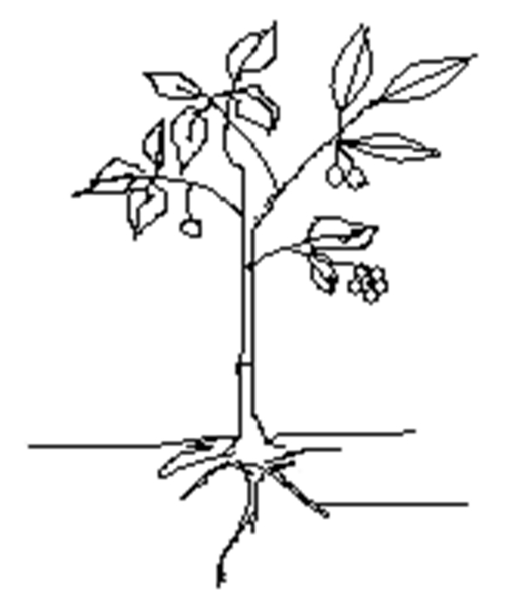

1. Name these animals

|  |  |
| --- | --- |
|  |  |
|  |  |

## **ENGLISH**

**Fill in the missing letters.**

(a)bi___ycle

(b) tra___sport

1. **Complete the sentence with the correct word.**

A _______________ of flowers.

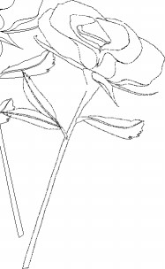

1. **Use the given words correctly.**
   1. He ______________under the tree yesterday. (sit)
   2. The teacher __________the books in the shelf last week. (put)
   3. My father ______________to Nairobi last year. (drive)
2. **Write as instructed.**

a) Musa went to the airport. He did not see the aeroplane.

(Join the sentences using: ……but….)

_________________________________________________________

c)The bird is flying in the air. The aeroplane is flying in the air.

(Join the two sentences using: ……………and…………..)

__________________________________________________________ __________________________________________________________

1. **Write one word for the underlined group of words.**
   * 1. Mr. Mukasa bought a blanket, bed sheets, a pillow and a bed. _______________
     2. We have red, blue green, and yellow t-shirts. ___________
     3. The carpenter made chairs, tables, desks and benches. ________________
2. **Make sentences using the following words.**

a) right

__________________________________________________________ b) write

__________________________________________________________

1. **Choose a correct word to complete the sentences.**
   * 1. A _________________sails on water. (sheep, ship)
     2. We get _________________from animals. (meat, meet)
     3. My grandmother always ______________on the mat.

(seat, sit)

1. **Give the singular noun.**
   * 1. teeth __________________
     2. oxen __________________
     3. children __________________
     4. women __________________

**1. Multiply**

(a) 2 X 3 =_____________ (b) 4x3=__________

(c) 2 2 (d) 1 0 x 3 x 3

_______ ________

* + 1. Seven times three equals __________________
    2. Put 3 eggs on each plate. How many eggs are there on 5 plates?

_________________________________________________ 2. **Form groups of threes**.

= _________ threes

(

)

a

_________ threes

=

)

b

(

**3. What pairs of numbers add up to 6?**

* + 1. _______________ + _______________ = 6
    2. _______________ + _______________ = 6

**4. Add correctly**

(a) 1 2 eggs (b) 3 6 pencils

+ 8 egss + 8 pencils

___________ _____________

* + 1. 2 7 books (d) 4 4 cakes

+1 5 books +1 6cakes

_______________ ______________

1. Peter had 26 hens. John had 9 hens. How many hens did they have altogether?
2. Mummy bought 15 kilograms of suger. Daddy bought 18 kilograms of sugar. How many kilograms did they buy altogether? (g) Find the total of 5, 2 and 7, _________________